 | Inventions |  |  | 
 | Year Group: 2 | Subject Focus: History | Term: Autumn 2
Key facts  - George Stephenson worked in a coal mine from being a child and he never went to school.  - He taught himself how to read and write.  - He invented a locomotive to move coal around.  - In 1829 he entered a competition to invent a locomotive that would travel at 30 mph and he won!  - The locomotive he invented was called ‘The Rocket.’  - Trains became very important in Victorian times for travel and transport.  - Queen Victoria was the Queen of The British Empire from being 18 years old.  - She became queen in 1837.  - George Stephenson died in 1848  - Queen Victoria died in 1901.  - Diesel trains started to be used in the 1930’s.  - Steve Jobs starting inventing parts for computers in the 1970’s and carried on until 2011. |  | Parents as partners:  - Visit Thwaites Watermill, Temple Newsam Farm, Leeds Industrial Museum at Armley Mills, Leeds City museum or Abbey House museum to see how machinery has been used in Leeds for centuries.  https://museumsandgalleries.leeds.gov.uk/  - Go on the water taxi and see the waterways of Leeds and how they helped our city to grow. https://www.leedsdock.com/the-voice/leeds-dock-water-taxi/  - Walk to Cross Gates train station and watch some of the trains. Do they all look the same? How far do the trains travel?  Exciting books/ web links:  https://www.bbc.co.uk/bitesize/topics/zd4dy9q  https://www.bbc.co.uk/bitesize/topics/zn3vvk7/articles/zh7m8hv  https://www.bbc.co.uk/bitesize/topics/zn3vvk7/articles/zsydr2p  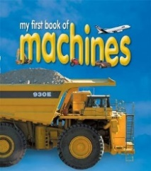  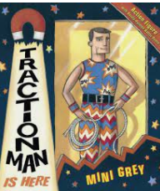  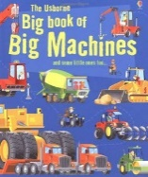  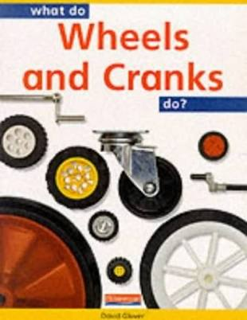 | Key words:  achievement a thing done successfully with effort, skill, or courage  chronology the arrangement of events in the order they happened  design to make or draw plans  diesel an engine that uses fuel not steam  era a long and distinct period of history  engine a machine that uses energy from fuel or electricity to do work, such as to move  event a thing that happens or takes place, especially one of importance  famous Known about by many people  first hand directly experienced by somebody  identify find out about
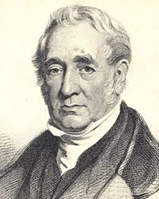

Key people/ places
George Stephenson was an inventor who invented ‘The Rocket’ – one of the very first trains.

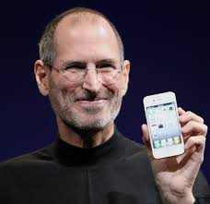
Steve Jobs was a designer and
inventor who created Apple
computers. He earned a lot of
money and gave lots of it to
charity.

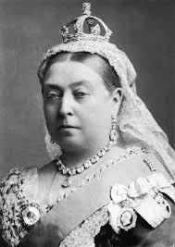
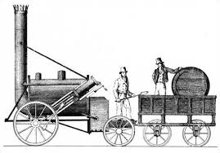

Timeline

                      
1819 1829 1837 1901 1930 2020

