 | Art: Craft and Design
 | Year Group: 2 | Subject Focus: Art | Term: Spring 1
Skills:  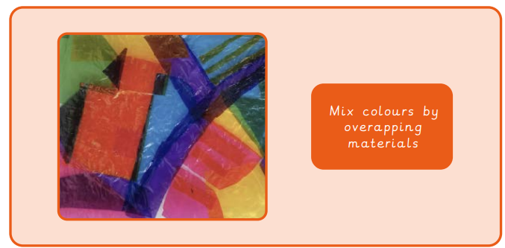  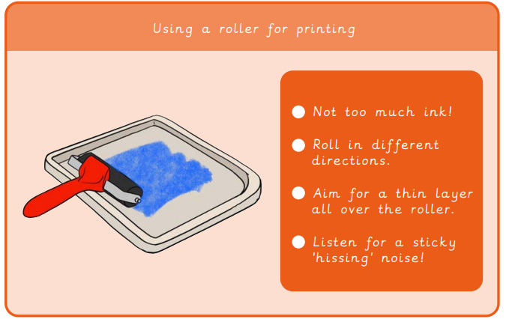  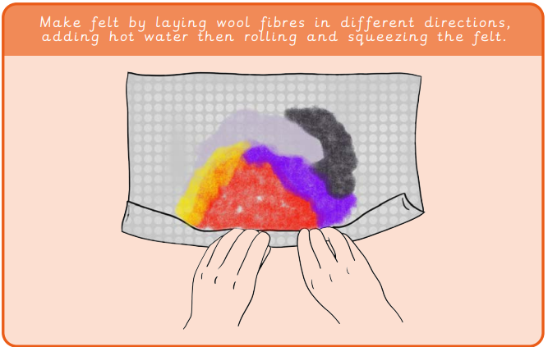 |  | Famous Artwork:  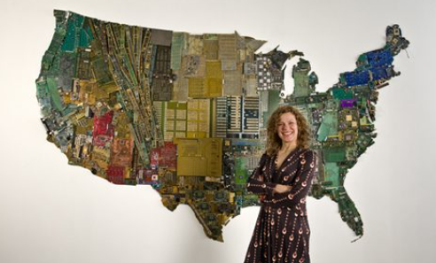  Susan Stockwell  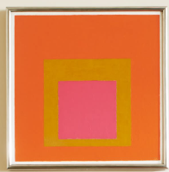  Josef Albers  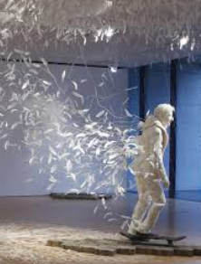  Kim Soon Im | Key words:  abstract Where the subject doesn’t look like it does in real life.  composition Putting different elements together in a pleasing way.  curator Someone who organises and looks after collections in a museum.  felt A material made by squashing fibres together.  fibre Threads of wool.  light Brighter and bolder.  negative print Ink that shows the background rather than the picture.  pattern A design in which shapes, colours or lines are repeated.  stained glass Colourful decorative glass that makes a design.  texture The surface of a piece of art.  About the artists:  Susan Stockwell  - Born in Manchester in 1962.  - Makes sculptures, collages and drawings.  Josef Albers  - American-German artist born in 1888.  - Famous for his painting of squares.

