 | Art: Drawing
 | Year Group: 2 | Subject Focus: Art | Term: Autumn 1
Skills:  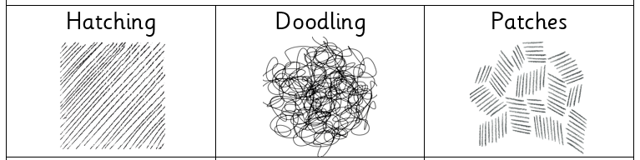    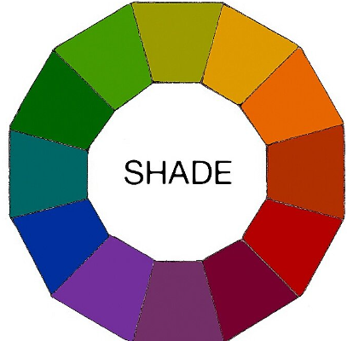 |  | Famous Artwork:  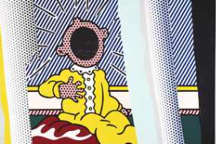  Lichtenstein: Reflections on the scream  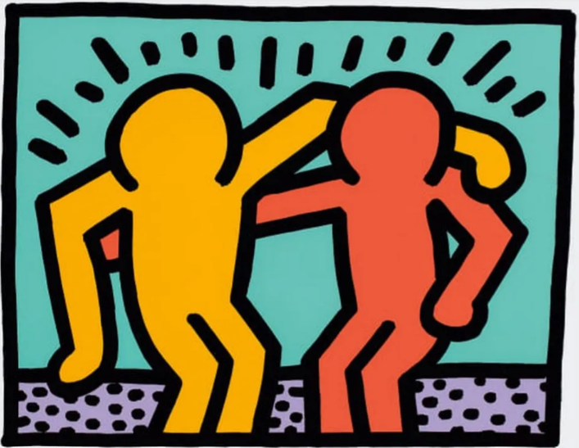  Haring: Best buddies  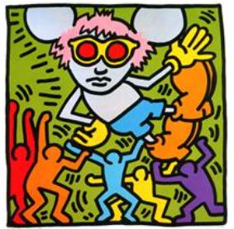  Haring: Andy Mouse | Key words:  blending Rubbing or smudging to create a gradual transition to soften lines.  doodling Freely draw patterns and images.  form The techniques used in a piece of artwork.  hatching A style of shading with parallel lines  light Brighter and bolder.  patches Small sections of hatching.  shade Dulling down a colour with black to make it darker.  shadow Darker areas blocked by light.  sketch Drawing an outline quickly with many small strokes.  texture The surface of a piece of art.  About the artists:  Roy Lichtenstein  - Bornin in New York (USA) in 1923.  - Famous for bright colours.  - Drew comic strips and cartoons.  Keith Haring  - Born in Pennsylvania (USA) in 1958.  - Loved drawing cartoons and visiting museums.  - Known for his love of bold colour.

