 | Weather and Seasons |  |  | 
 | Year Group: 1 | Subject Focus: Geography | Term: Summer 1
Key facts  - The weather changes regularly and tends to be different during different seasons and across different countries.  - Weather symbols are used as a ‘quick’ and ‘easy’ way to show the current weather happening on certain places.  - There are differences in the weather, length of day light and plant life during different seasons.  - In ther UK there are four different seasons. Each season has a different type of weather.  - Winter is cold, wet and windy. It snows in some areas and gets dark early.  - Spring brings warmer weather. Flowers start to grow and baby lambs are born.  - In summer the weather becomes hotter; there is less rain but there may be more thunderstorms.  - The weather starts to get colder in autumn. Leaves change colour and fall off the trees. |  | 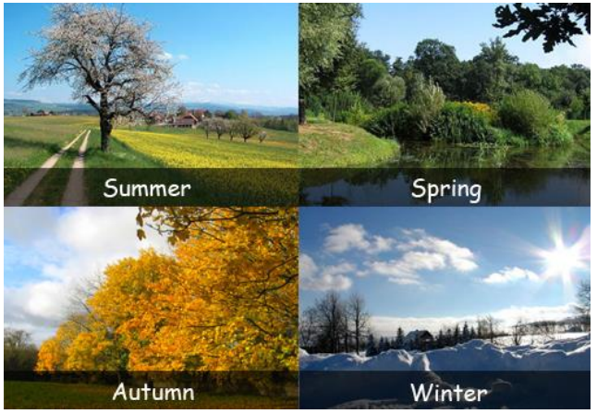  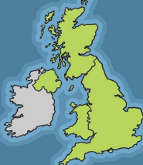  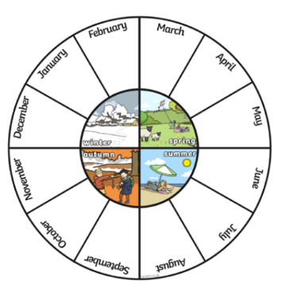 | Key words:  Seasons A time of the year with a particular type of weather  Spring The season after winter and before summer.  Autumn The season after summer and before winter.  Winter The season after autumn and before spring.  Summer The season after spring and before autumn.  Temperature How hot or cold it is  Forecast Explaining what the weather will be like  Symbols Pictures or signs that help us understand something  Observations What you notice when you look carefully at something.  Thermometer An instrument used to measure temperature.
Weather
These are different types of weather. What is your favourite type of weather?

Can you keep a record of the weather for a whole week?
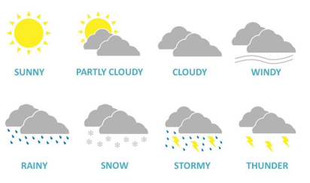

 |  | 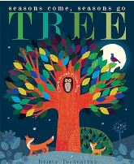  Exciting books/ web links:  Tree: Seasons come, seasons go  https://www.bbc.co.uk/bitesize/topics/zwv2wnb/articles/zcx3gk7  https://www.bbc.co.uk/bitesize/topics/zwv2wnb/articles/z7dkhbk | Parents as partners:  - Create a weather chart and record the daily weather patterns and temperature.  - Explore your local area and see what signs of spring you can see.  - Can you draw a picture of each season

