  Topic Geography:    In Geography this term we are going to be learning all about the weather. We will learn about the four seasons and different types of weather we find in them. Year 1 will learn how to observe and record the different weather types and explore how weather affects the clothes we wear. | English:  Year 1s English focus this half term focuses on a range of modern Fairy Tales. We will explore the key themes within these tales and use our key text Cinderella for Talk for Writing which will then support us in writing our own retelling of a fairy tale! We will also explore writing a non-chronological report.  Phonics:  In preparation for the Phonics screening check (w.c June 10th, 2024) Year 1 will be doing lots of practice in school of reading both real and alien words.  Maths:  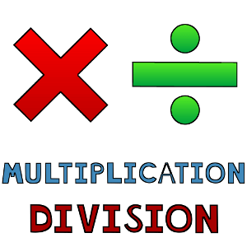  Continuing our learning we will move onto multiplication and division which focuses on making equal groups, arrays and sharing. This reinforces our learning of counting in 2, 5 and 10s.  Fractions and Geometry will also be covered. | Home Learning  Please support your child by reading the two books sent home every Friday, and returning the book bags by the latest every Thursday.  Spellings are also given out every Friday, which are to be practiced for the ‘Spelling Quiz’ the following Friday.  Accessing NumBots at home will also help improve your child’s maths abilities.  Supporting with phonics:  ✓ Immerse your child in a love of reading: share books and magazines with your child, take them to the library to choose books, read to them regularly, point out texts around you e.g. in the street etc.  ✓ Make time for your child to read school books to you regularly – encourage them by pointing to the words and ask them about the story they are reading.  ✓ Help your child to practise reading key words and sounds  Useful links:  https://www.phonicsbloom.com/  https://www.phonicsplay.co.uk/
Other Subjects:
Science: Continue our learning of Plants
PSHE – Drug, Alcohol & Tobacco Education. What do we put into our bodies?
RE – How and why do we care for others?
History – Changes within living memory
Computing – Lego Builders & Animated story books
DT – Make a puppet
PE: Kwik Cricket & Invasion Tag.

Tuesdays and Wednesdays. If your child wears earrings, please make sure that they are taken out or covered before school on these days.

