 | DT: Structures (creating a windmill)
 | Year Group: 1 | Subject Focus: DT | Term: Spring 2
Key facts:  - Windmills can be used to grind grain into flour, to pump water or to produce electricity.  - There is nearly 10,000 wind mills in the UK alone!  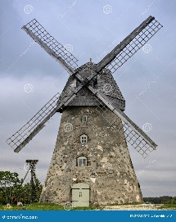  We Are Learning To:  - Design stable windmills that can stand on their own and catch the wind.  - Evaluate our designs and discuss how we can improve them for next time.  - Develop our problem solving skills and understand how a design can serve a purpose. |  | Technical Knowledge:  A wind mill has an axel, similar to ones that cars use that help connect the sails and enable them to spin around with the wind.  Windmills need to have a rotor, which will help the sails to spin around.  Windmills need to have a strong structure to help the sails stay strong and not topple over.  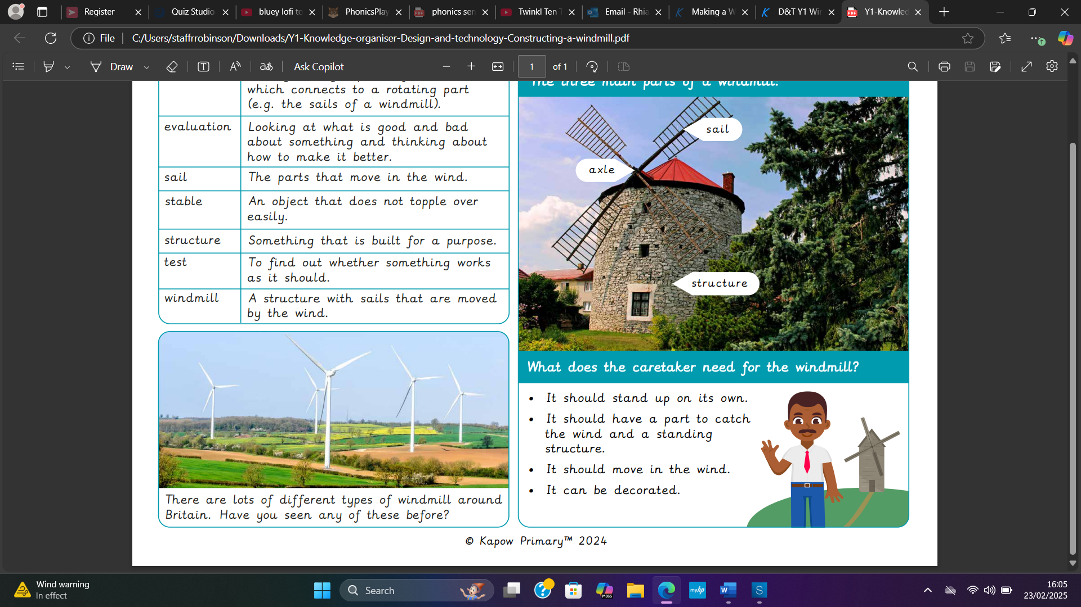  What will your windmill look like? | Key words:  Axle A long straight piece of material that connects to a rotating part  Evaluation Looking at what is good and bad about something and thinking how to make it better  Sail The part that moves in the wind  Stable An object that does not topple over easily  Test To find out whether something works as it should  Structure Something that is built for a purpose  Windmill A structure with sails that moves by the wind  Design A plan to show the look and workings of a building  Rotor Blades The long airfoil that rotates  Rotor The rotating part of an electric machine, such as a generator.  .  Real life:  - Daniel Halliday made the first windmill in 1854.  - Daniel was an inventor, machinist and businessman.  - Daniel was the first person to make a windmill move to face the direction of the wind.  