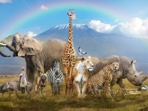 | Animals |  |  | 
 | Year Group: 1 | Subject Focus: Science | Term: Autumn 1
Key facts  - Animals vary in many ways having different structures e.g. wings, tails, ears etc. They also have different skin coverings e.g. scales, feathers, hair. These key features can be used to identify them.  - Animals eat certain things - some eat other animals, some eat plants, some eat both plants and animals.  - Humans have key parts in common, but these vary from person to person.  - Humans (and other animals) find out about the world using their senses.  - Humans have five senses – sight, touch, taste, hearing and smelling. These senses are linked to particular parts of the body. |  | 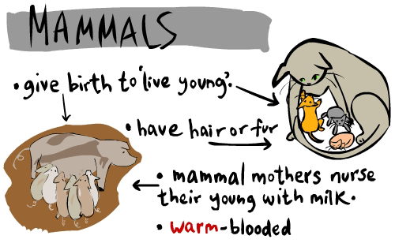  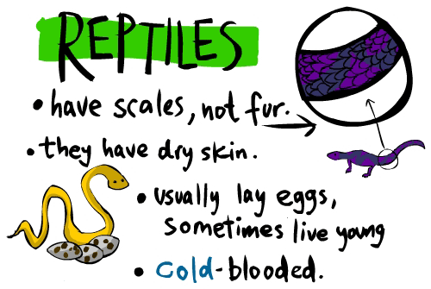  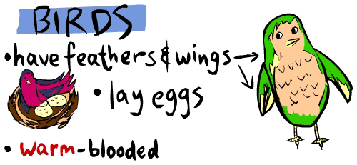  Types of Animals  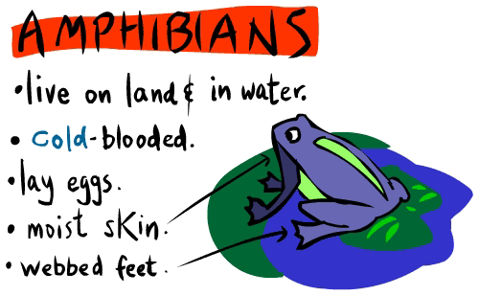  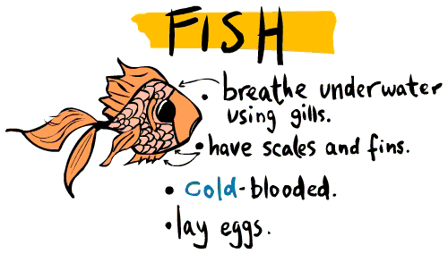 | Key words:  amphibian a cold blooded animal that can live on land and in water. They have a backbone and most lay eggs.  carnivore an animal that eats meat  herbivore an animal that only eats plants  omnivore person or animal eats all kinds of food including both meat and plants  leg legs support an animal's body and allow it to move  mammal an animal that breathes air, has a backbone, and grows hair at some point during its life. They give milk to their young.  reptile an air-breathing animal that has scales instead of hair or feathers. They have a backbone and most lay eggs.  tail A tail is the section at the rear end of an animal's body  wing The wings of a bird or insect are the two parts of its body that it uses for flying  feathers Feathers are lightweight growths that cover a bird's body. All birds have feathers, but no other animals have them

Key places

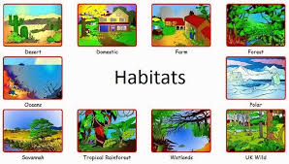

 |  | Exciting books/ web links:  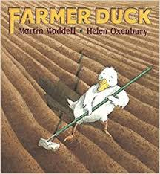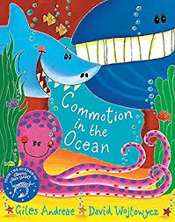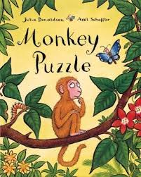  https://www.bbc.co.uk/bitesize/topics/z6882hv  https://planningplaytime.com/preschool-songs-body-parts/  https://www.nurseryrhymes.org/body.html | Parents as partners:  - Visit Tropical World, Temple Newsam Farm or Lotherton Hall and find out what the different animals eat.  - Visit Leeds City museum to see the stuffed animals and skeletons.  - Draw your favourite animal and label its body parts – what other animals are similar?

