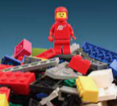 | Toys Then and Now |  |  | 
 | Year Group: 1 | Subject Focus: History | Term: Summer 2
Key Questions  - How long have toys existed?  - What were toys made of during the Victorian age?  - What toys did Victorian children play with?  - What are modern toys made of?  - How are modern toys different?  Key facts  - Our local area has changed over time, and so have the lives of the people who live here.  - Some toys and games are thousands of years old.  - Dolls are one the earliest forms of toy to exist.  - Teddy bears were invented over 100 years ago.  - We can compare the differences between toys now and in the past by asking other grown-ups questions, reading books and using the internet to find out information. |  | In the past children played with different games and toys depending on whether they were a girl or boy/ rich or poor.  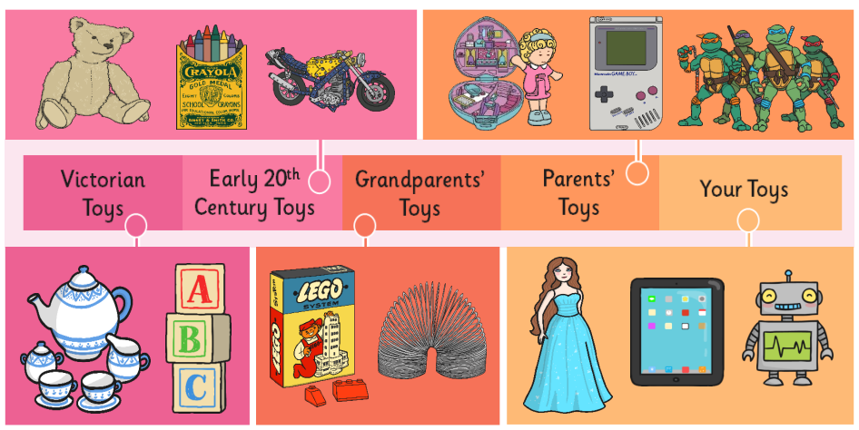 | Key words:  decade  past  present  old  new
 |  | Exciting books/ web links: | Parents as partners:  - Look at old family photographs together and compare what looks the same and different to now.  - Discuss your toys and school life in the past, or ask older members of the family. What is the same? What is different?

